Monday | Tuesday | Wednesday | Thursday | Friday
 |  |  | 1 | 2
5 | 6 | 7 | 8 | 9
12 | 13 | 14 | 15 | 16
19 | 20 | 21 | 22 | 23
26 | 27 | 28 | 29 | 30

Friends Place Richardson  All meals served with Iced Tea or Lemonade and Fresh Baked Bread unless otherwise indicated.  For NCS diets-Fresh Fruit, ½ portion regular dessert or sugar free cookie/pudding is offered.  For no added salt diets-Table salt is not available. |  |  | BBQ Chicken  Baked Potato  Peas  Cole Slaw  Gingerbread | Lasagna  Italian Flat Beans  Garlic Bread  Caesar Salad    Peach Cobbler
Parmesan Crusted Chicken  Sweet Potatoes  Imperial Vegetables  Cole Slaw  Chocolate Cake | Steak Fingers with Gravy  Seasoned Fries  Peas  Spinach Salad  Strawberry Parfait | Baked Fish  Macaroni & Cheese Green Beans  Butternut Squash Soup  Orange Fluff | Beef Pepper Steak  Over Rice  Broccoli  Eggroll  Green Salad  Fresh Baked Cookie | Chicken Tenders  Au Gratin Potatoes  Scandinavian Vegetables  Caesar Salad  Brownie
Bratwurst  Mashed Potatoes with Brown Gravy  Squash Capri  Green Salad  Apple Cobbler | Turkey Spaghetti  Italian Flat cut beans  Garlic Bread  Cole Slaw  Pumpkin Dessert | Meatloaf  Rice Pilaf  Broccoli  Caesar Salad  Strawberry Shortcake | Chicken topped with Spinach  Roasted Potatoes  Beets  Green Salad  Vanilla Pudding | Tomato Bisque  Quiche Lorraine  Peas & Carrots  Spinach Salad  Carrot Cake
Marinated Chicken  Rice Pilaf  Squash Capri  Cucumber & Tomato Salad  Brownies | Stuffed Green Peppers  Corn  Carrots  Vegetable Soup  Lemon Jell-O Cake | Thanksgiving Feast  Turkey with Gravy  Cornbread Stuffing  Sweet Potatoes  Green Bean Casserole  Green Salad  Pumpkin Pie | THANKSGIVING DAY  CLOSED | THANKSGIVING  HOLIDAY  CLOSED
Garlic Herbed Chicken  Scalloped Potatoes  Carrot Cascade  Caesar Salad  Pistachio Fluff | Parmesan Breaded Tilapia  Corn Soufflé  Broccoli  Green Salad  Fresh Baked Cookie | Baked Ham  Macaroni & Cheese  Scandinavian Vegetables  Spinach Salad  Cheese Cake w/Toppings | Vegetable Lasagna  Italian Flat Cut Beans  Garlic Bread  Cole Slaw  Pound Cake w/ Toppings | Sheppard’s Pie  Corn Bread  Cup of Fruit  Cup Of Vegetable Soup  Banana Pudding
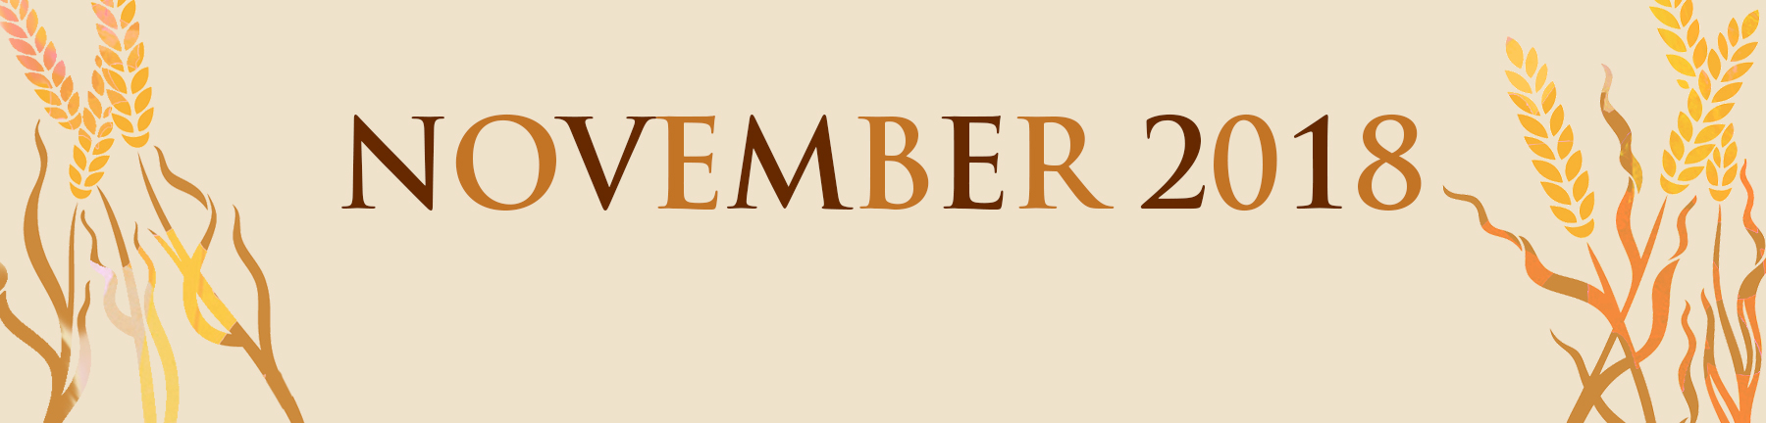
Menus approved by:_______________________________________________Date_______________________________________

